Collaborative Scheduling Algorithm for Prioritized Tasks

# Architecture:

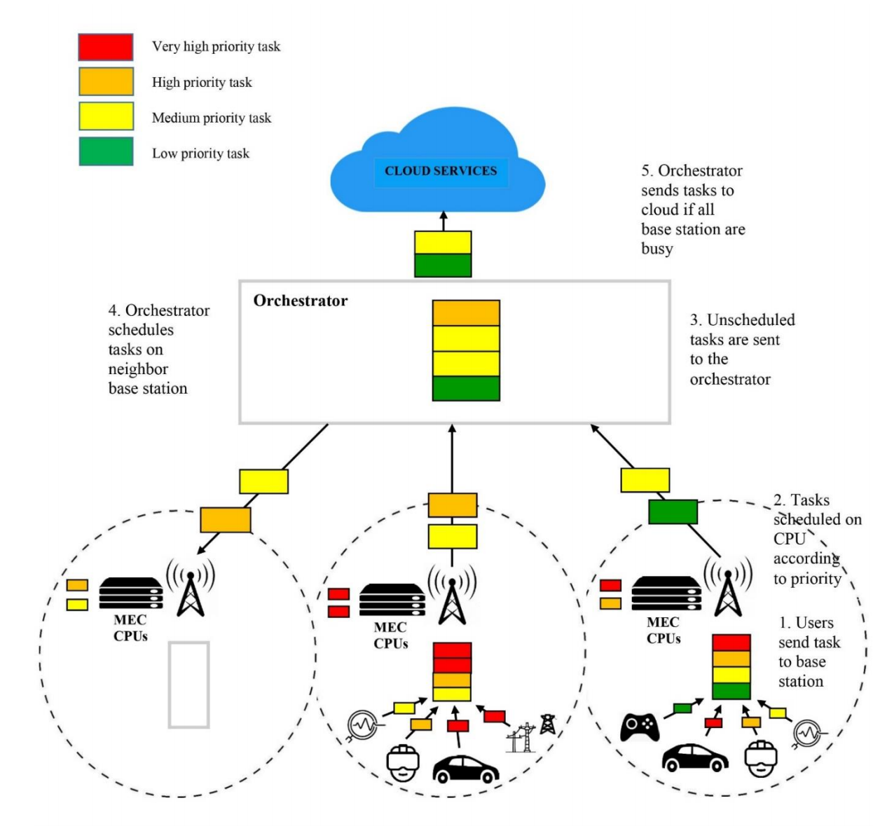

**IoT- End user Device:** N number of user(devises) connected to base station, they send jobs to Base Station for processing, wait for the response to submit next job.

**Base Station**: receives jobs from connected users **(N number of users connected to BS)** , it processes the request based on priority and responds to end user devises. If the load is more then it sends jobs to orchestrator. Base station schedules jobs based on FCFS and Priority.

**Orchestrator**: orchestrator has the list of bas station and gets status details of BS dynamicaly, it will tri to put the jobs which are received by base station (that has more work) to other base station that has less load. In worst case ( where orchestrator could not find any base station that has less load) will pass those jobs to Cloud server(cloud server has unlimited resources ), Cloud server will perform the remaining task with in that slot. **There will be M number of base stations** managed by Orchestrator.

**Cloud Resource**: has unlimited resources to process the jobs.

**Design:**

# Sequence Diagram:

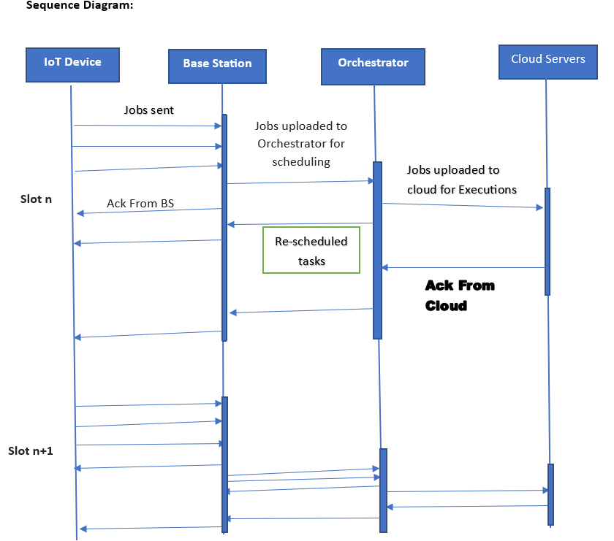

# Algorithms:

# Orchestrator Server: Collaboration Algorithm:

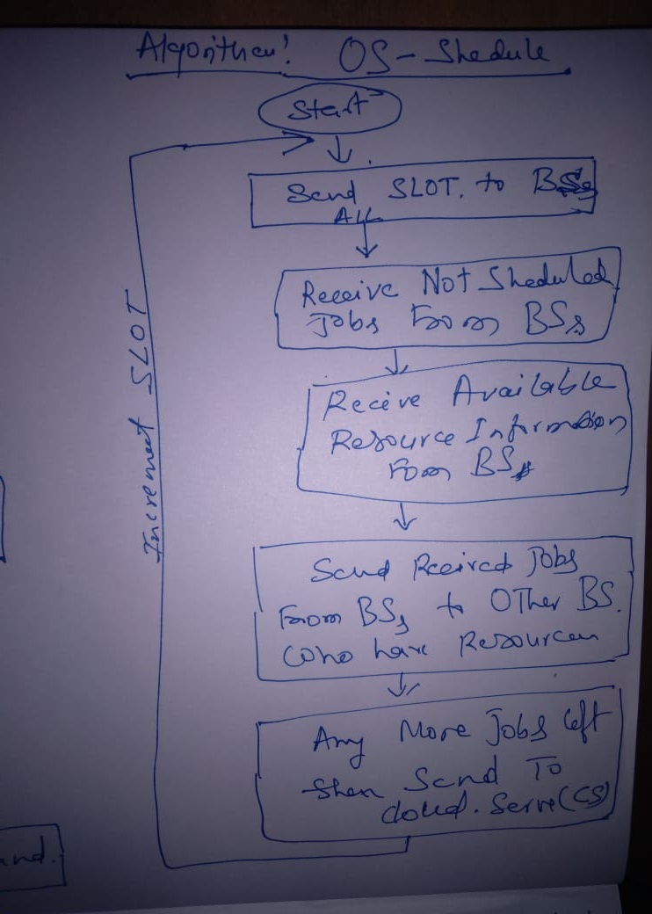

# Base Station: Prioritized Task Scheduling Algorithem:

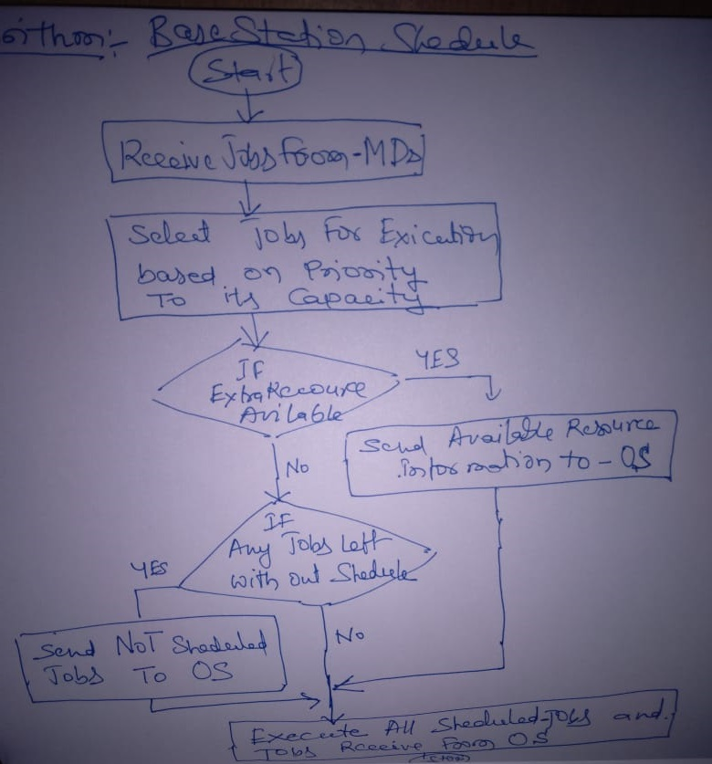

# User Interface:

## Mobile Device:

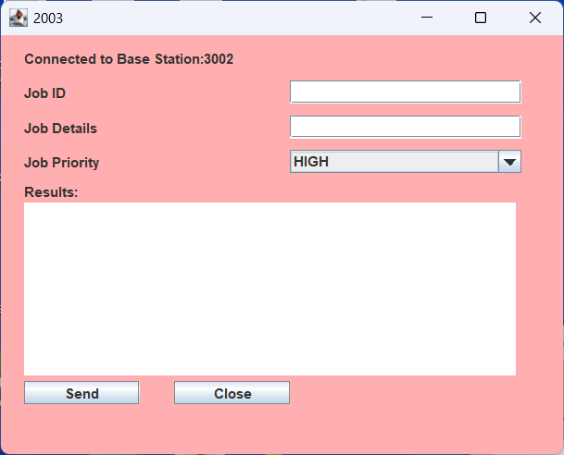

## Base Station:

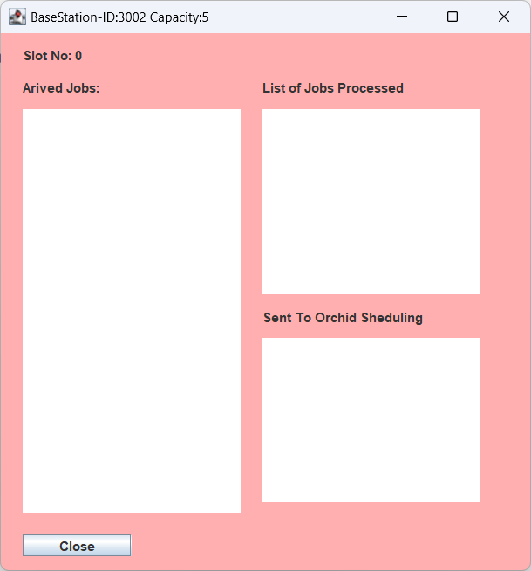

## Orchestrator:

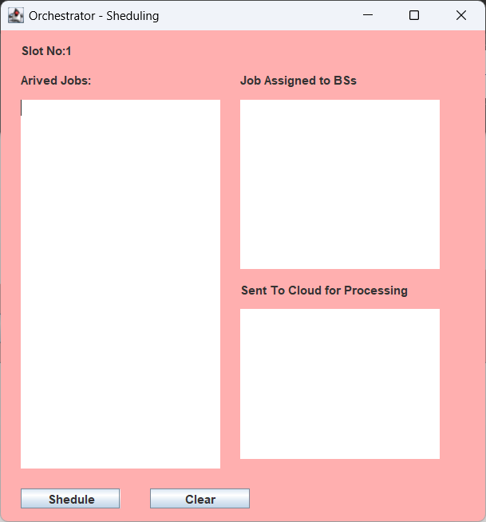

## Cloud Data Centre:

